Tom Lewis – Apprentice Boatbuilder
Peninsula Marine Services, Plymouth
Mid-year progress report Feb 2022
http://peninsulamarineservices.co.uk/
Dear sir’s
I am pleased to submit my mid-term report.

The tasks I have been working on in the workplace vary from gel repairs to stripping masts for resprays. I am doing a variety of different jobs each week, which is helping me gain a range of different skills and a better understanding within the shipwright industry. I am currently really enjoying my apprenticeship and have a strong willingness to gain new skills and knowledge. I think my apprenticeship has benefitted the company well because of my enthusiasm, eye for detail and to complete a job as efficiently as possible, whilst maintaining a quality finish. I found the gel repairs tough at first because I didn’t have a great understanding of how gel repairs work and what the correct ratios with the catalyst and pigments etc. I now have a good understanding of how to do gel repairs, thanks to my workmates who have shown me what preparation has to go into it and have given me tips and tricks with gel repairs. I mainly found the colour matching the most difficult part. I am improving more and more each time I do a repair and I’m committed to become more skilled in the area. What I enjoy about my apprenticeship is the variety of different skills you gain as you are doing something different most days and is multiskilled. My plans and goals for the future is to become a fully qualified shipwright and to have a reputation for having a good quality of work. I have gained so many different skills so far on my apprenticeship and I am constantly learning new things as there is so much to learn within the industry.

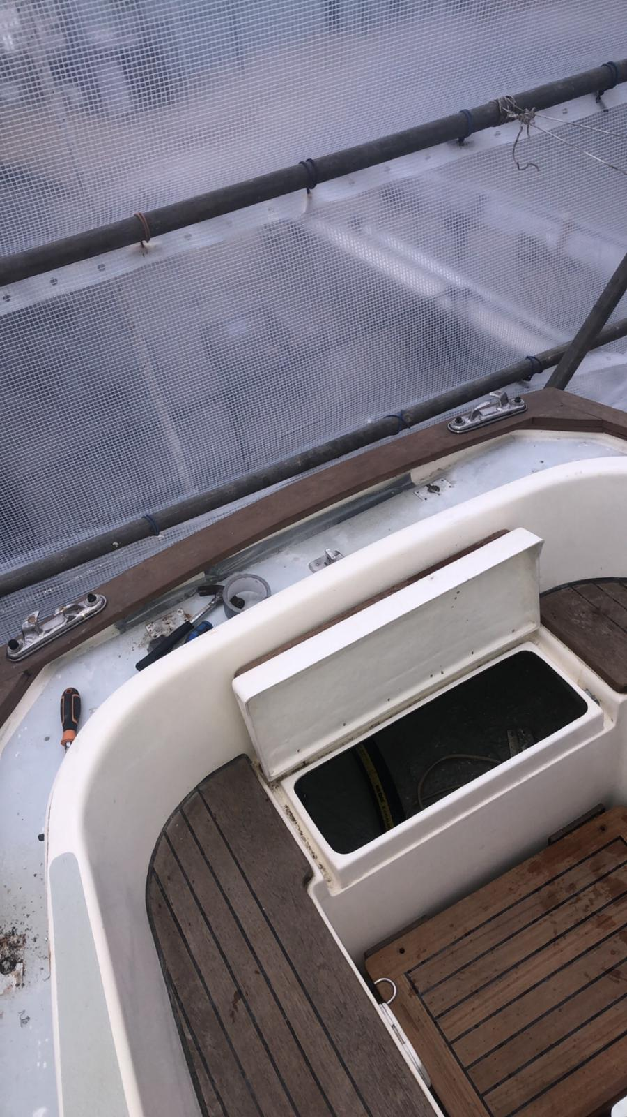
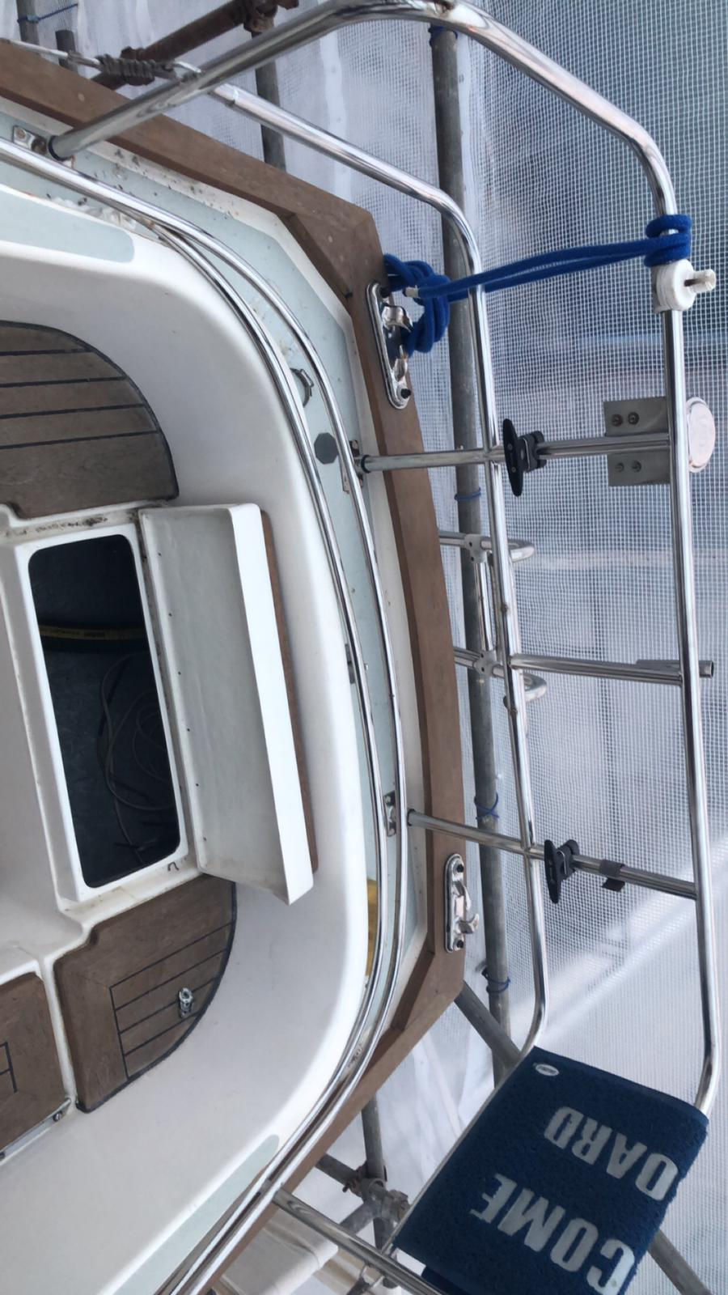
In the photos above I had to dismantle the stanchion posts so that the deck could be sanded and primed so that a new cork deck could be fitted. The access to the nuts where a struggle because I could not see what I was doing and only had a small access hole to work with.

This is the gel repair I recently did, I enjoyed doing the repair and was my first time doing it. I first used a Dremel to smooth off the edges so that the new gel could bond more easily. I then mixed up some Cabo seal and the colour matched gel which then acted as a filler. Next, using a brush I brushed on a coat of gel and catalyst with a small amount of MW solution which acts as a wax and makes it easier to sand. I then built up the grades of the sandpaper from 180 grit to 800 grit so that once flat and flush it could be polished without seeing the scratches from the sandpaper as anything from 800 grit can be polished with no problems. I look forward to improving in the area.

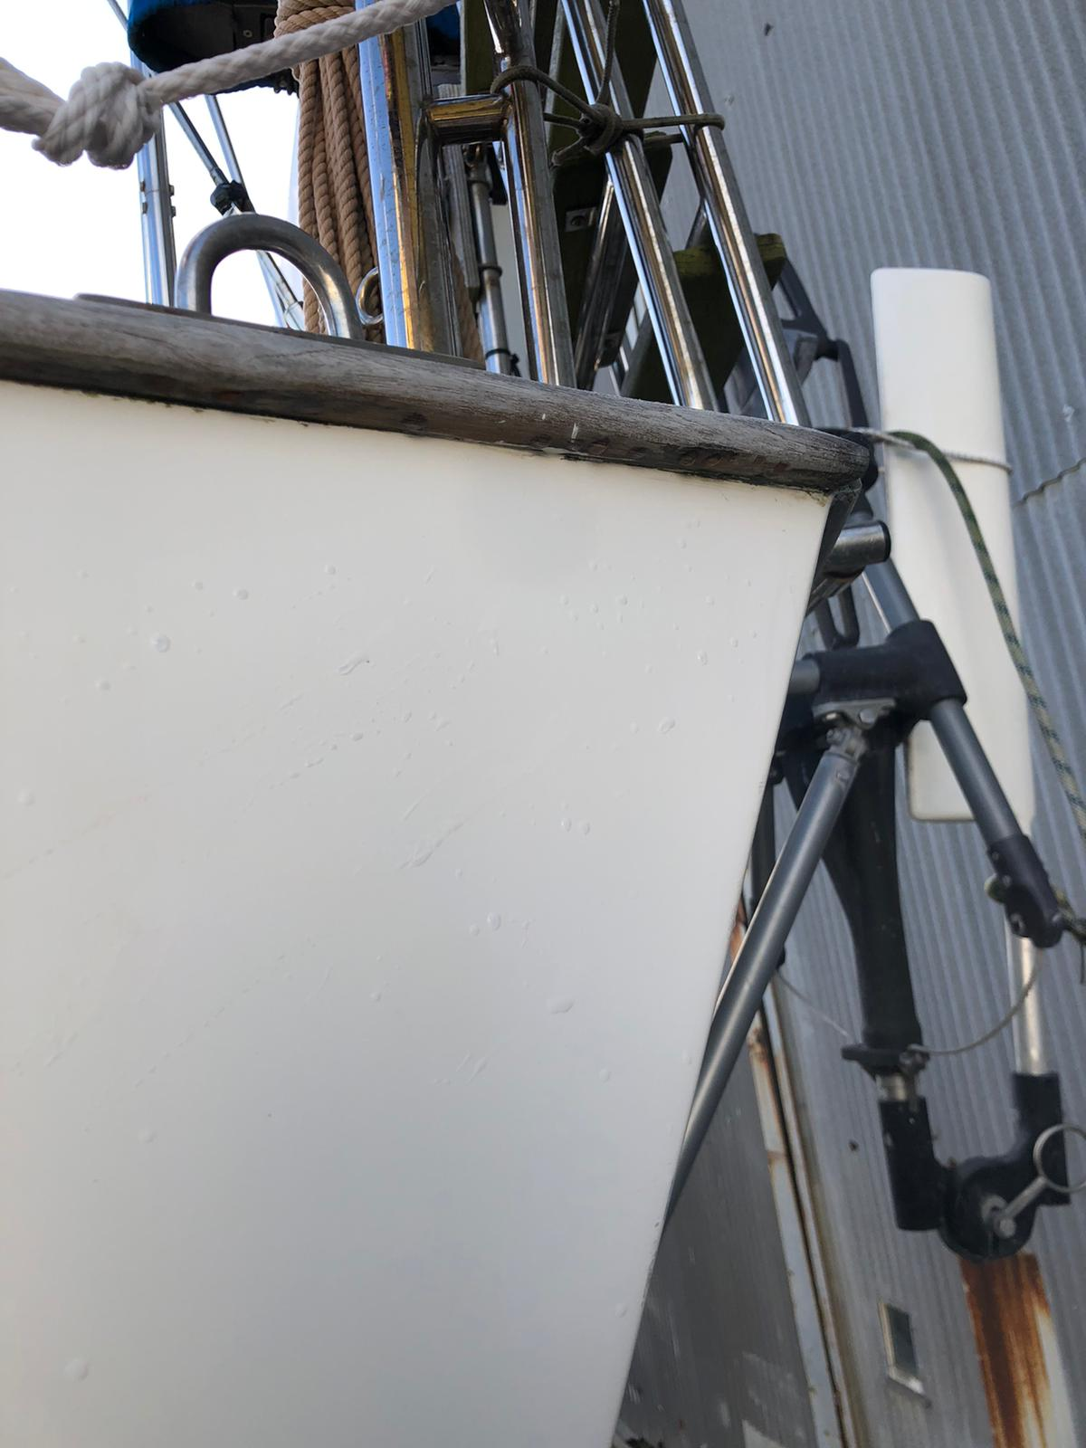
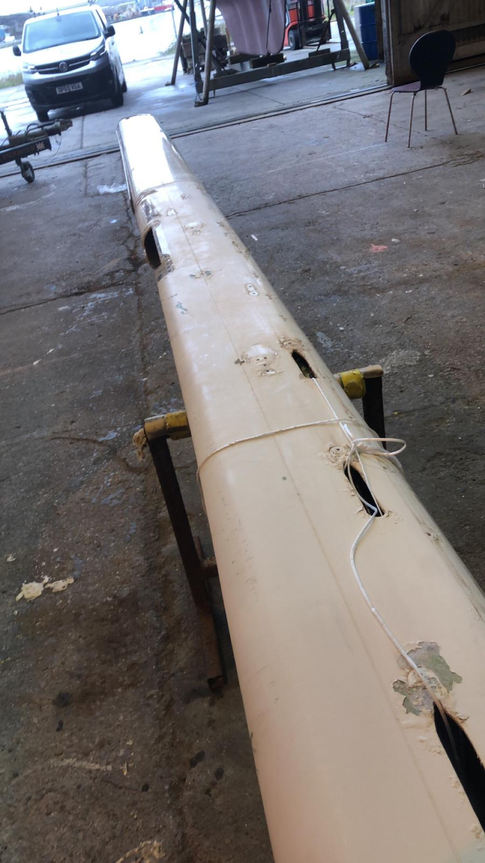

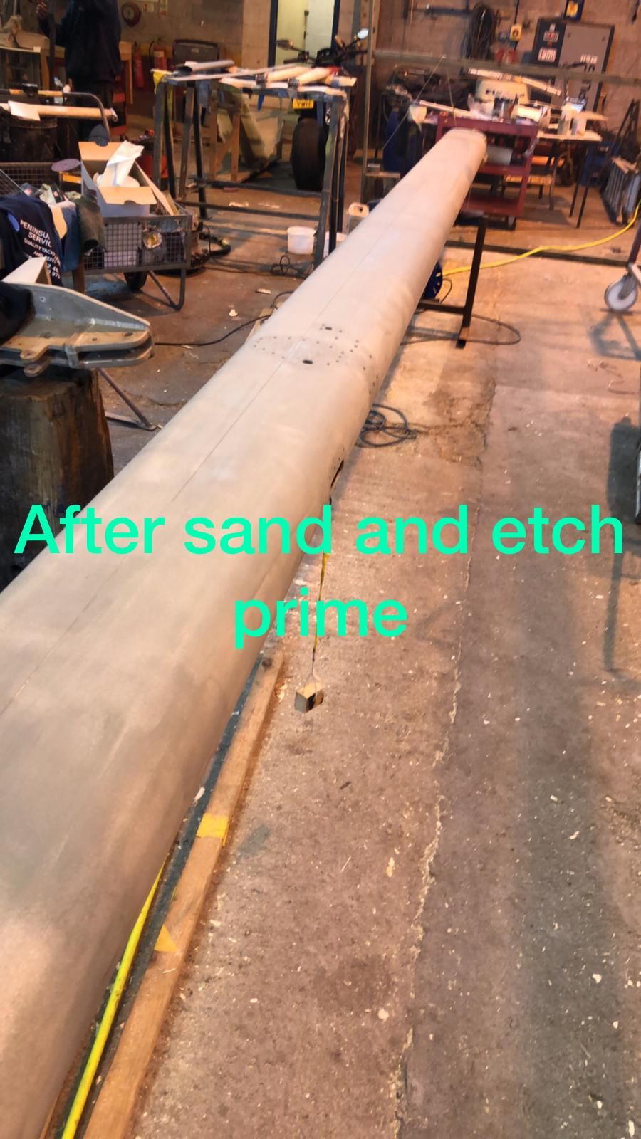

This is the mast that had to be stripped due to corrosion which led to the paintwork flaking and peeling off. First, I had to sand the old paint off mostly down to the bare metal so that the paint process could begin. I used an etch metal primer which was the first coat of paint that was put on. After the etch primer, another primer called light primer, as you can’t paint topcoat directly over an etch primer.
Thank you for the opportunity for the sponsorship.
Yours Sincerely

Tomas

