**Theo Aers, Apprentice Marine Engineer**

**Servowatch Systems Ltd, Essex**

**Mid-year progress report Feb 2022**

**http://www.servowatch.com/**

I am Theo Aers, and I am 17 years old, and I was fortunate enough to receive the opportunity of an apprenticeship at Servowatch. Servowatch is a marine automation and integrated systems solutions provider that is currently in the process of becoming part of the Rolls Royce Group. Throughout my short amount of time at Servowatch I have been part of many of the projects to get an understanding of how the company operates and what work is involved to produce, and supply some of the leading ship automation systems.

I have really enjoyed learning about the capabilities of these sophisticated control systems and look forward to being involved in the constantly improving technology in the Marine Engineering world. From the beginning I was very interested in learning about how these systems work and the extent of their capabilities. At first, I found the software element challenging and it was not easy to understand how it operated. However, now I have a greater understanding I have learned to enjoy it and involve myself in this part of my work when I have the chance.

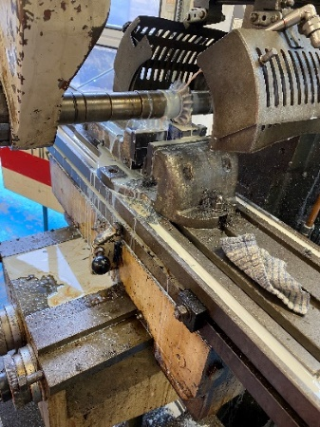Alongside my work at Servowatch I also attend Colchester Institute on Mondays and Thursdays to improve my fundamental engineering skills as part of my Level 3 Engineering Technician qualification. I am currently learning the skills to operate lathes and milling machines as well as wiring and testing electrical equipment. Both of these different sectors cover a large range of basic engineering skills and will provide valuable stepping stones and knowledge for my career as a Marine Systems Engineer. In October I also took part in a CAD course which I found very interesting and beneficial. Later on, this year I will also be doing MIG welding training which I look forward to as I have never had the opportunity before.

Turning down steel on a Lathe

Horizontal Milling Machine

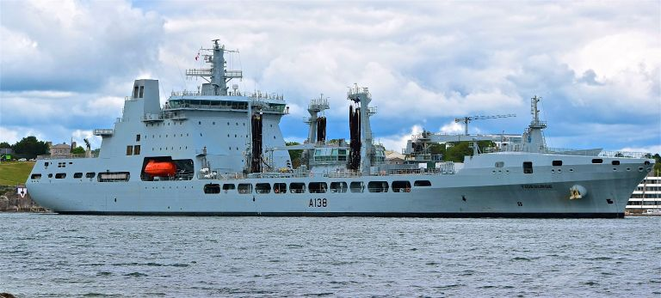

RFA Tidesurge

Main Control Room

In January, I took part in sea trials aboard RFA Tidesurge, a Tide-class replenishment tanker of the British Royal Fleet Auxiliary. We first joined the ship in Plymouth and spent a day in harbour where I spent a lot of time in the Main control room as we were trying to optimise the control of propulsion system. We set off the next day to see how the ship performed at sea and tried to get a further understanding of what optimisations were possible. I really enjoyed the experience and learned a lot and it has massively helped me understand more about Servowatch systems and their purpose.

**Projects I have been working on**

One of the main projects I have been involved in is a land-based simulator which is being built for the MARS Fleet of tankers for the crew to practice and learn about how to operate and control the Servowatch systems before doing it in a real-life scenario. My job for this project was to create the displays for the control panels as shown in this picture.

A display for the Land based system

A Further Project I have been involved in is a new system being fitted to the RFA ships which I have created the HMI pages for on a software called Factory Talk View Studio. I have found this particularly interesting as it has assisted me in understanding what needs to be monitored on these types of vessels and why is it so important.

In summary, my first 6 months with Servowatch have been interesting and challenging at points, but I have already learned a huge amount about my role and how the company operates. I have had no second thought about choosing this pathway and I am very grateful for the Worshipful Company of Shipwrights for supporting me through this brilliant opportunity.