Owen Freeman – Apprentice Marine Engineer
Jenkins Marine, Poole
Mid-year progress report - February 2022
https://jenkinsmarine.co.uk/

Tasks
Some of the various tasks I have completed at Jenkins marine range from things such as, cleaning and painting to rebuilding drive legs and removing/rebuilding engines.
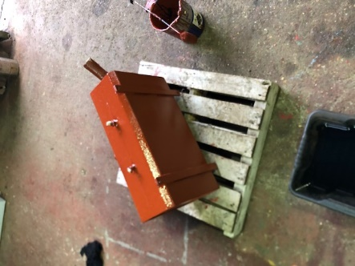
One of the first tasks when I started Jenkins marine was to prep and paint various parts of a powerpack.
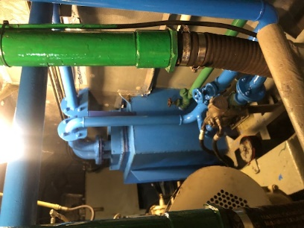
As well as the power pack I had to prep and paint pipe work on one of our tugs.

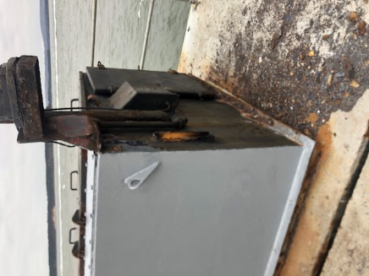
Another one was an engine canopy on one of our hopper barges.
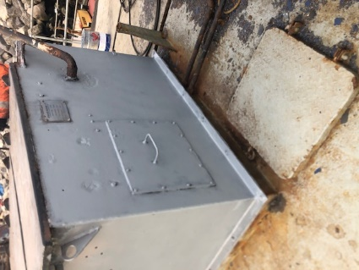

As the time has gone on here I have begun to get into more interesting things such as, drive leg rebuilds, removing engines, removing and fitting various engine components, servicing and maintaining engines and equipment. Some of the more recent jobs I have done are:
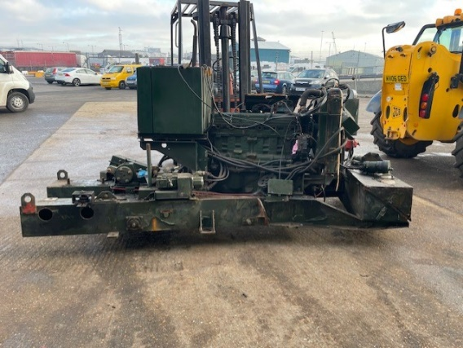
Stripping down an old army unit getting it ready for a barge.
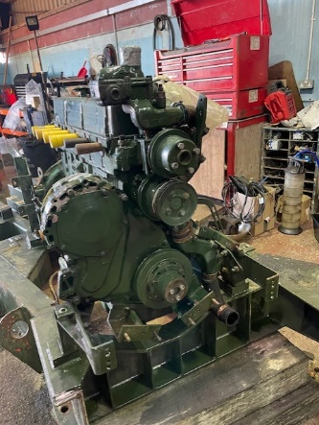
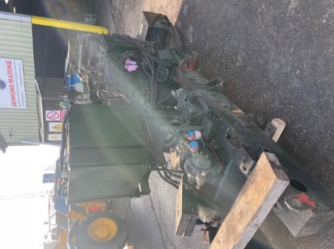

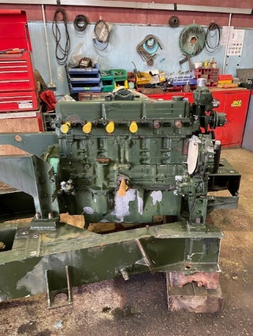
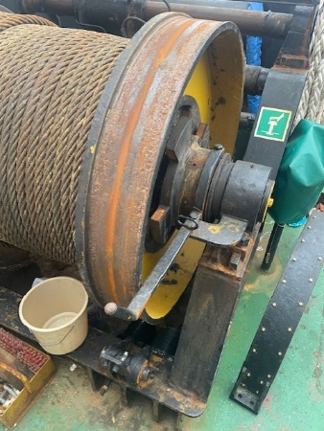
Taking off and replacing a brake band on a winch
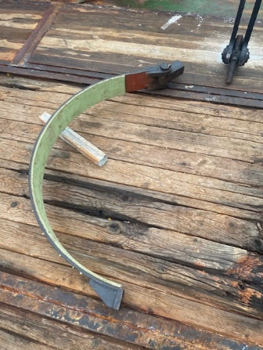

Rebuilding a drive leg
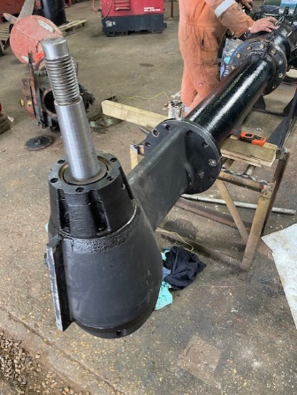
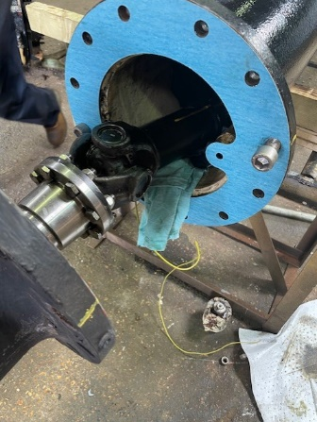
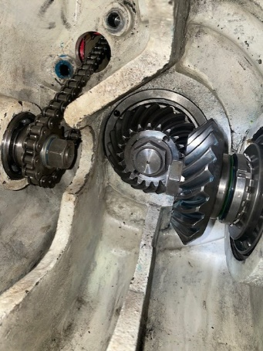

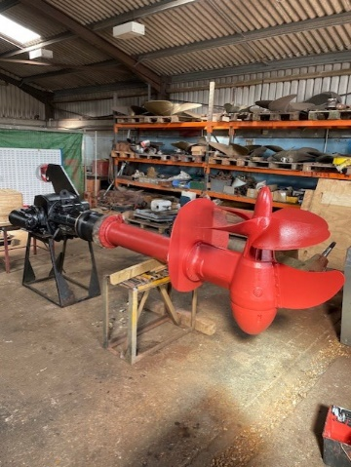

That is a short summary of the many tasks I have performed whilst at Jenkins
Off the job training
The off the job training at college has helped me by giving me more of an understand about marine systems and their use and how they operate. I have also done various online courses like abrasive wheel, manual handling, COSHH and confined spaces. I bring this knowledge back to the workplace and use it to help me in situations where something is not working etc. An example of when off the job training has helped me is when working in a confined space. I was aware of the hazards that were around me, the precautions and the correct safety gear to use.
What I have enjoyed
At Jenkins the thing I have enjoyed and found most interesting the most is working with the boats and going into depth about how they work.
What I have found difficult at the start
At the start of the apprenticeship, I found it difficult to be able to go on my own and perform various tasks whereas now I enjoy going on my own to perform the tasks.
My knowledge and skills I have developed
I have developed more knowledge within the marine industry, along with vessels how they operate and work. I have also gained a little bit more knowledge on use of tools that I haven’t used before. Some of the skills I have developed are more of a problem solving mind ie finding ways around things.
How my apprenticeship has benefited the company
I think my apprenticeship has benefited the company by being able to teach a new worker in the marine industry and being able to use my knowledge and skills acquired from college etc to bring into the workplace. I also think it has benefited the company by showing they are willing to take on apprentices to give younger workers a chance to be able to get into the marine industry. I think there has been a few positive impacts it has made on the local community by again showing they are willing to take on and teach younger workers.
Plans and goals
My plans and goals for the future is to be a fully qualified marine engineer climbing up the career ladder and pushing myself to become the best at what I do. Eventually I plan to be working on cruise ships as a marine engineer.

