Joshua Allsopp, Apprentice Marine Engineer
Smith’s Boatyard, Wadebridge, Cornwall
Mid-year progress report, February 2022
https://www.smithsboatyard.co.uk/

The Stelios Philanthropic Foundation sponsored apprentice 2021-22
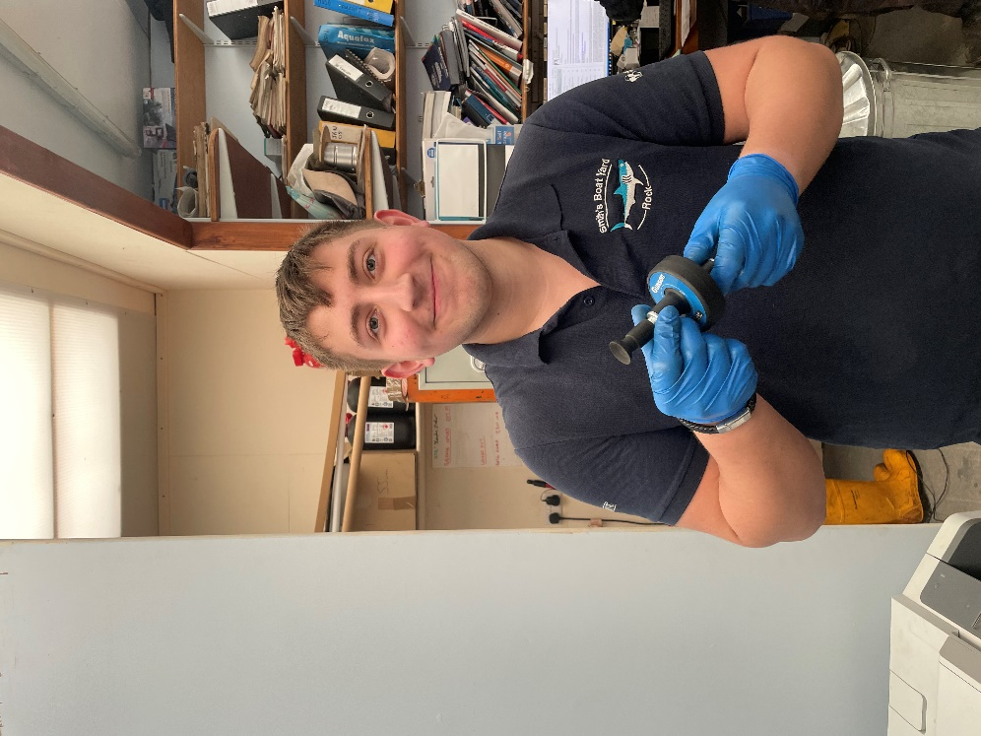
Josh Allsopp

Meet Josh Allsopp…
Josh is 17 years old and ever since he was a small boy he has been tinkering with marine engines and boats, being born and raised on the North Cornish Coast. In the summer of 2021 he started a period of work experience for Smith’s Boatyard in Wadebridge. During this time he learnt about outboard motor servicing, changing impellers, changing oil and seals the gear oil and other rudimentary skills such as helping to launch and recover boats – as well as the all essential boat washing and cleaning.
He left school with good grades in English and Maths and then attended Falmouth Marine School where he completed the BTEC level 2 in Marine Engineering. Therefore it was a natural progression to commence the apprenticeship with Smith’s Boatyard and take the next step at Falmouth Marine School with the level 3 Marine Engineering apprenticeship standard.
Josh recently submitted his mid-year report to us and it makes impressive reading, particularly as he only formally started the apprenticeship six months ago.
-------------------------------------------------------------------------------------------------------------------------------------------------
“Ever since I started my apprenticeship in September 2021, I have learnt so much and I have had a huge development of my knowledge and have done this by completing lots of tasks varying from services and winterizing to also completing tasks such as head rebuilds/refits. I have done this on a Yanmar 1gm10 Cornish shrimper engine which had insufficient compression and needed the valves changed and re-seated. During this I removed the head of the engine where I then removed the valves and swapped them for new ones. When you install new valves, you must ensure to lap them in. This can either be done by hand or with a drill, it allows the valves to sit nicely on the head ensuring the compression of the engine is up to spec this is especially important of diesel engines due to it being harder to ignite then petrol. However, the condition of the head was particularly bad on this engine so it had to be sent off to be machined before I could properly lap the valves. Once I did this, I reinstalled the head. And finally serviced and winterized the engine.
I also refitted the head of a 3-liter MerCruiser inboard. When I did this, I had Shaun (my supervisor) who previously took apart the engine during the summer walking me step by step, showing and explaining to me the easiest and best ways to do it. Before we did the rebuild Shaun got me to do research on the engine to find torque settings, and special fitting requirements, how to fit the hydraulic lifters, push rods, push rod cover, setting the valve clearances with the engine on and off, fitting of the manifold, carburetor, throttle linkages and timing procedure. After trying to start it we found we were having problems with the starter motor, so I removed it and connected it to a battery to see if it was working correctly which it was, so I then decided to clean the electrical terminals up which made the starter motor run much better. Once we did this, we found we were having trouble with the engine timing and spark, so we ended up changing the distributor cap and rotor along with retiming the engine allowing the engine to start. The first time the engine was stripped there was lots of water in the oil, so we had to do a double oil change to ensure all of the contaminated oil was removed. The first oil change was to add temporary oil to the engine so that we could run the engine knowing it had oil in. the second change included oil filter change, hydraulic lifters strip and clean and oil change this stops lots of contaminated oil mixing with the fresh oil.
One of my favorite tasks has been the service of the water taxi on the Camel estuary. Which I have done once when I was on work experience, and once since I started my apprenticeship. To do this we have to drive down the road to the estuary and drive the dinghy over to the taxi. The boat has 2 Nanni diesel engines connected to jet drives. Each engine takes 13 liters of oil. This typically takes 2 ½ to 3 hours to complete. I really enjoy doing this due to it being so different to typical work in the yard as it takes lots of preparation beforehand and working on the water is more challenging.
I find outboard services interesting due to most outboards being different and using different techniques within the engine. I have completed quite a few of these now and I have found that it's nice to work on new engines but on older engines there are often faults which are fun to try and correct. A common fault is dirty carbs - dirt commonly gets stuck in the jets in the carb and prevents proper amounts of fuel entering the combustion chamber. This can also affect the flow of fuel, making the engine run either rich or lean.
I have also recently done a little bit of fibre glassing work. It was on a broken cow shed roof, it had a large crack in it, and it needed to be fibre glassed. Throughout this I had Andrew (company owner) walking me step by step through each process and each stage to ensure the best finish possible.
At college (Falmouth Marine School) I was tasked to remove the head of a 4-cylinder Vetus engine. I was able to do this comfortably due to work I have done at the boatyard. I used skills and techniques I picked up when doing similar jobs.
The Worshipful Company of Shipwrights is greatly beneficial to us. They allow me to spend more time on jobs to ensure I do the best I can, this also allows me to shadow or someone to shadow me so I can get a greater understanding of the problem/job. I would greatly recommend an apprenticeship to other people following a similar path to me, as I have greatly improved my skills and my knowledge and have also given me a great head start in the industry especially saying before my apprenticeship I had little engineering experience in the workplace.
Below (and on pages 4,5 & 6) are a selection of photos of me carrying out various tasks over the last six months…”