

Jack Pearce, Apprentice Boatbuilder
Zenith Marine, Plymouth
Mid-year progress report, February 2022
https://www.zenithmarine.co.uk/

Dear Andy,
Here is my report on the skills I have experienced and developed, I have gained so far during my apprenticeship with Zenith Marine.
ON THE JOB EXPERIENCE
Although I’m only a few months into my apprenticeship I was very lucky to be offered the opportunity to work in Germany and be involved in a re-fit for five superyacht tenders. This was an experience I will never forget adding to my motivation of pursuing a career in this industry.
Whilst I was working in Germany, I also got to witness the full effects of managing a big project like this. All the components from including engines, drives, navigation equipment, electrics and teak was removed from the five tenders leaving a bare shell.
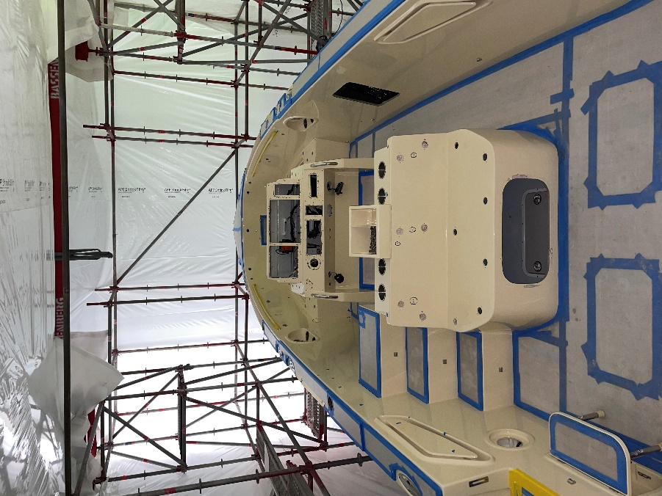 (I will send some finished photos once the project has been completed)

Three of the tenders went into preparation ready to be re-sprayed by a company called PKC, As the other two tenders were gelcoat and not being sprayed, we could start the work on them. A number of repairs were carried out on the GRP from where damage had occurred, this was a skill and challenge I was really looking forward to learning. I assisted with several repairs being carried out step by step giving me an understanding of the process is taken to complete the repair. For example, colour matching with the right amount of pigment and catalyst ratios.
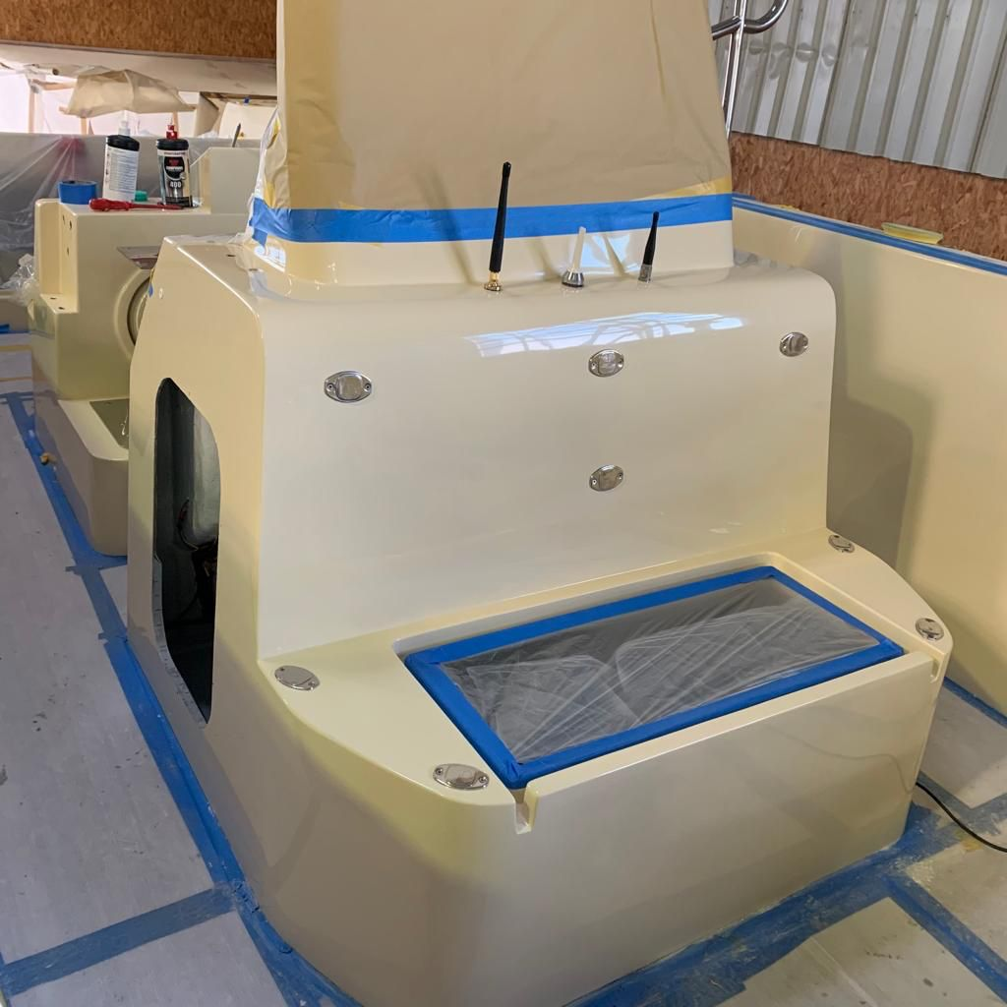
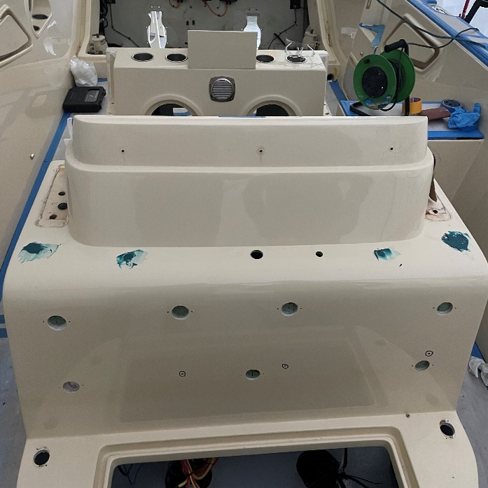

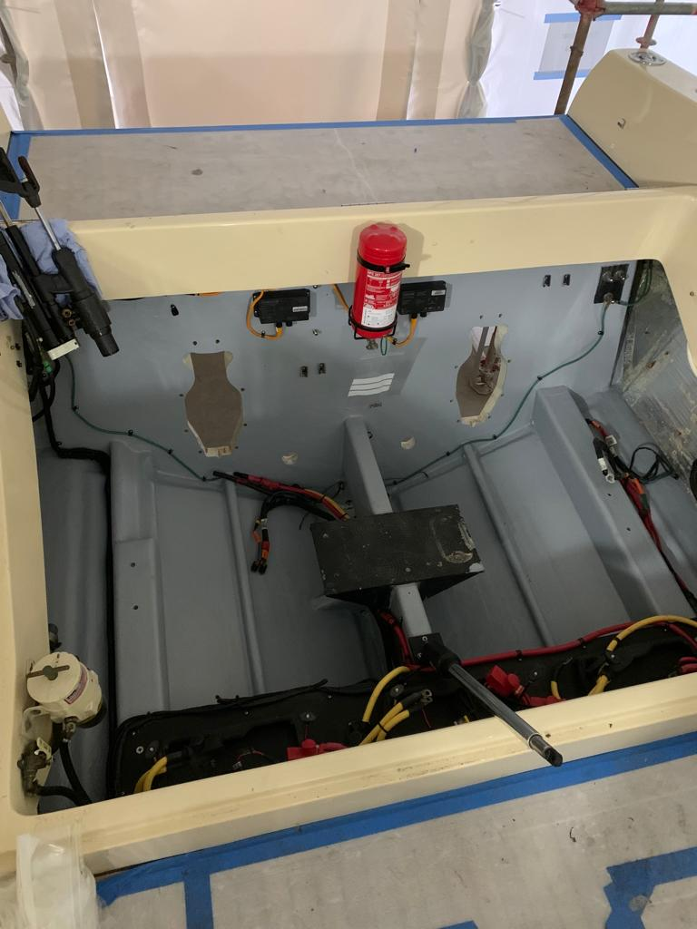
All the engine bays and lockers were etched and received a top/flow coat leaving a brand-new finish, this wasn’t something I had not done before and learnt it could have been a very messy job without the right guidance and was very satisfying to see once it was finished.

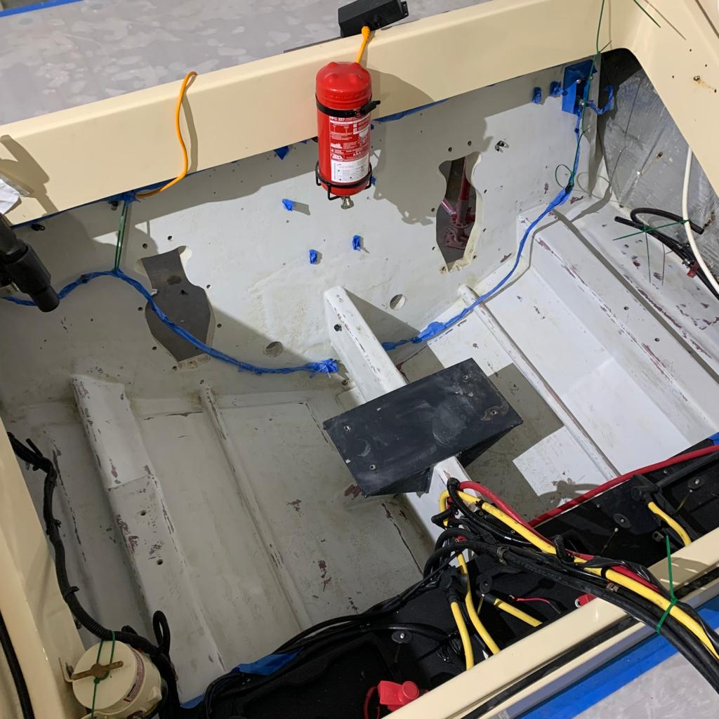

I also got to assist with some problem solving, we needed to find a solution to prevent water from entering a lifting point on the forward deck which was causing water damage to the bow thruster mechanism. Due to the customers requirements the lifting strop needed to be always out. The solution to solving the problem was to fit an inspection hatch plus 50mm from the lifting point. The inspection hatch would allow for easy access to install a box around the lifting strop under the deck fitted with a drainage system to prevent any further damage. Installing the inspection hatch would also allow for another access point to the thruster mechanism. Once the hole was cut for the new access hatch the surplus foam core was removed and refilled with epoxy charged resin 20mm deep. Carbon backing plates 40mm wide & 5mm were cut and installed using blots and epoxy glue.

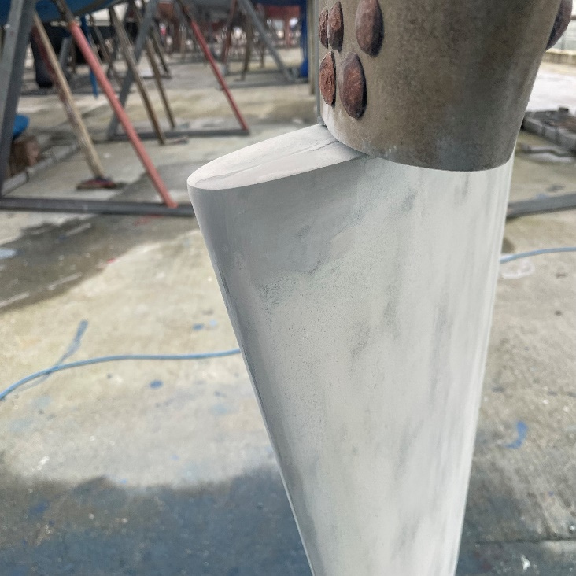
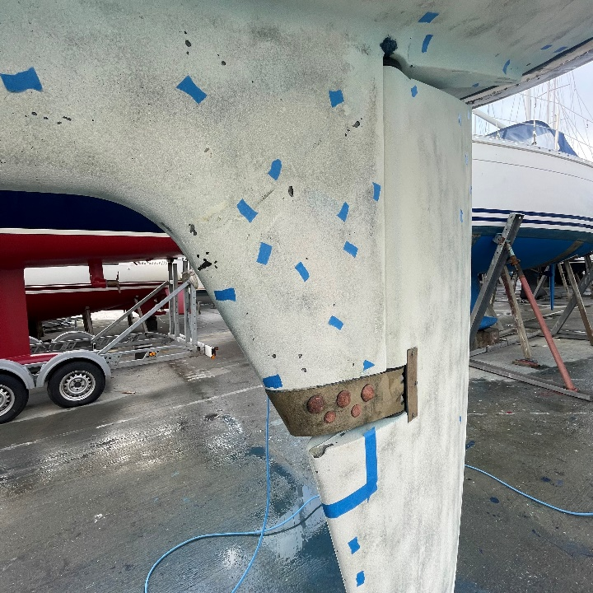
In the UK I have also been learning some underwater repairs, filling in voids and other damages that have occurred. At first this wasn’t something I was very confident of completing on my own but after being taught the correct ways to complete these repairs I now have the confidence to start and finish the job by myself.

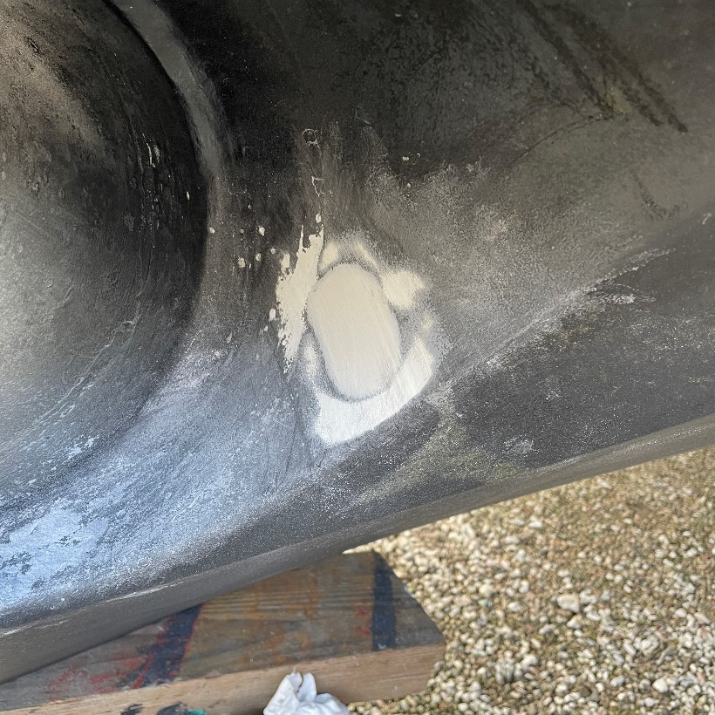
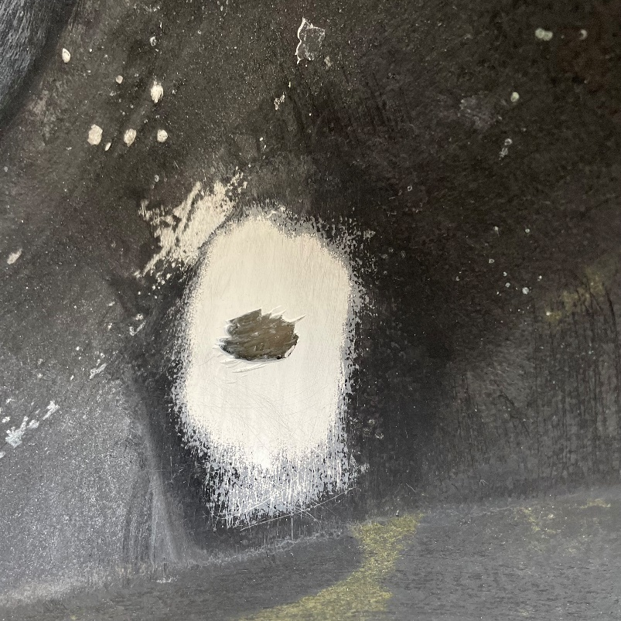

COLLEGE EXPERANCE
Although I’m only a few months into college we have covered a fair number of modules. The first 1-2 months a lot of the work was based on health and safety, and this was something I have covered when doing a course with Zenith so I has a good understanding when it comes to those assignments. We have also covered basic boat building operations and the tools used in the workplace also which methods needed to moving boats and the lifting equipment. I took an exam at the end of these modules and passed with a distinction. I’m looking forward to covering these modules in more detail so I can expand my knowledge.
The modules I have interesting and challenging at the same time were drawings and the corrosion of materials, I also passed this exam and I am looking forward to covering this in more detail.

