Ashlee Barrell – Apprentice Marine Engineer
Cox’s Boatyard, Norfolk
Mid-year progress report, Feb 2022
https://coxsboatyard.co.uk/
Dear the Worshipful Company of Shipwrights,
Since starting at college I have learnt a variety of skills. At my workplace I have carried out a number of electrical jobs such as installing a 40A Victron battery charger and 240v shore power system, inverter, extra batteries and solar panels. It was a challenging topic to start with but once I had carried out several jobs with the guidance from the engineer, it became easier and I could focus on my quality of work and understanding the topic further.
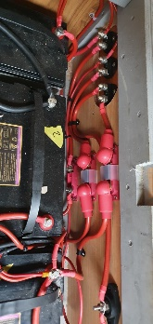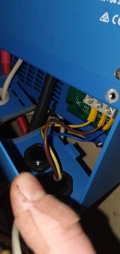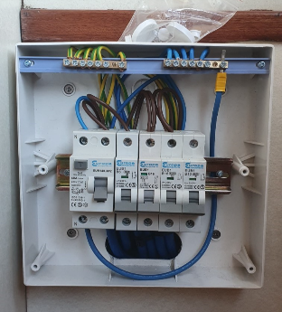
As well as this I have carried out a full engine swap by removing the old engine, creating new engine brackets, aligning the engine and applying all the auxiliary components which allow the engine to run.
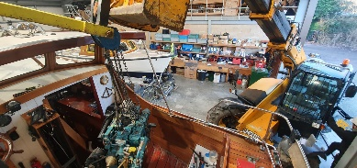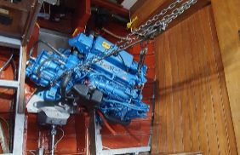
Over the winter I was taught how to service and winterise a craft, at the beginning I managed to complete this in 5.5 hours but by the end of the season I was completing the tasks in 2 hours. 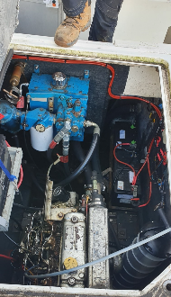
When at college, I have learnt a lot regarding safety procedures such as moving around the workshop, using tools correctly and what not to do in certain situations. Other topics included how to strip an outboard motor, how a marine business runs efficiently and why certain materials are used for components. This covered the topic of electrolysis (using anodes to stop corrosion).
Since starting working at Cox’s Boatyard, I have enjoyed carrying out an engine swap and the electrical work the most, I found it quite challenging but I was able to catch on quickly. Once I had the knowledge, I was able to improve my quality of work and greatly reduce my lead time for the company. On the other hand, I have found servicing difficult due to it being my first year carrying out the tasks but also the variety of different engines we have at the yard and that each system is manufactured in a slightly different which adds to the lead time. However, rather than not being able to complete the task, I found it hard to keep within a certain completion time but I have since managed to greatly reduce that.
As I mentioned previously about electrical being one of my most enjoyable topics, I used to find it the most difficult when I first started and it took a long time to improve my understanding and my hand skills. A year on, I can now say I have excelled at the topic, completing work at a high quality in a shorter period of time and hope to carry this mindset forward for not only this topic but all of my future jobs.
After beginning work at the yard and college, I have learnt a large variety of knowledge and practical skills, covering plumbing, electrical, engine systems, basic woodwork, safety management, how a marine business is run, allowing me to complete a number of tasks under the guidance of the head engineer.
My apprenticeship has benefitted Cox’s boatyard as it is training an engineer whilst being able to complete work for the company, therefore reducing project lead times. Working alongside the head engineer has taught me a wide array of practical skills as well as knowledge regarding the work we do. Once qualified, I will be able to complete more jobs by myself whilst maintaining a high work standard. I would like to go on to qualify in another area and push my skills, such as fabricating push/pull pits. This also has a positive impact on the customers as the turnover for their boat will be faster and the finish will be at an extremely high quality. This higher turnover and quality will add to the local economy as more customers will use our business and the local hospitality.
I aim to complete my apprenticeship on time and complete all the work that is set whilst also learning on the side, working with the head engineer to grow my knowledge ready for future projects. I would also like to go on to fabricate/TIG weld aluminium and steel for the company, creating tanks, push/pull pits and other components. I may also like the opportunity to help teach a future engineer apprenticeship like the head engineer has with myself.
Overall, I’d like to thank you for helping me onto my apprenticeship course and I hope the information I have provided is more than satisfactory.
Ashlee Barrell

