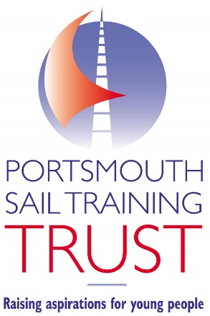
t 07725 480068
e ruth@portsmouthsailtrainingtrust.org
w https://portsmouthsailtrainingtrust.org/

Portsmouth Sail Training Trust c/o ASC Portsmouth
Eastern Road
Portsmouth
PO3 5LY

25th November 2021

Dear all at The Worshipful Company of Shipwrights,

On behalf of the Trustees and Beneficiaries of the Portsmouth Sail Training Trust (PSTT), I’d like to take this opportunity to thank you for awarding us a grant of £1,700. Your generous support will enable us to raise aspirations for young people – thank you so much.

Absolutely everything the Trust does is driven by our belief that all young people have the ability to excel and succeed in life and work. PSTT seeks to reach these young people by providing professional training and qualifications that help them reach their potential and meet the employment demands of the maritime industry.

Nautical training is at the heart of PSTT. A combination of water-based and land-based training is used, enabling young people to achieve commercially recognised qualifications vital to their career prospects. Most importantly, the programme aims to raise young people’s aspirations and develop their life skills, such as confidence, teamwork, problem solving, communication and leadership

The continued and generous support we receive from organisations like yourself is vital to the continuation of PSTT. We truly appreciate your support.

Together, we can raise aspirations for the young people of Portsmouth. Thank you.

Kind regards,

Richard Percy,
Chief Executive

