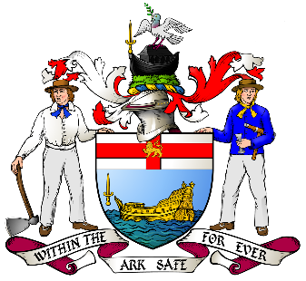
Will Tewson, Rob Perry Marine, Axminster, Dorset
The Sir Stelios Apprenticeship, the Shipwrights’ Apprenticeship Scheme

Hi, my name is William Tewson and this is my final progress report for shipwrights whilst working at Rob Perry Marine.
I have thoroughly enjoyed my first year working at rob perry marine as an apprentice because it has shown the variety of work, we carry out as marine engineers. A few of these job roles entail learning:
- How to carry out fibreglass repairs,
- How to overhaul an engine,
- How to prepare the hull of a boat for painting,
- How to weld and fasten metal and other materials together,
- How to carry out gelcoat repairs to a high standard on any vessel,
- How to wire components into existing circuits,
- How to troubleshoot a faulty engine.
- How to repair trailers and set them up correctly for the designated boat.
And many more...
I love how varied the job can be as it means that you come across a different scenario each day, so you are always learning something new.
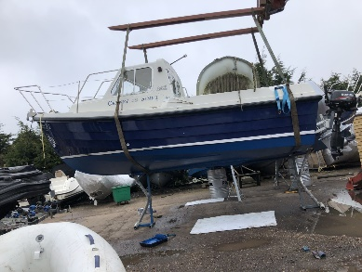
In March I showed my initiative by revolutionizing the way we antifoul boats. I did this by discussing the issue with Rupert and we found some boat stands that Rupert had left over in the yard to put the boat on, instead of having to crawl under the boat and trailer. By doing this it meant that I could manoeuvre under and around the boat much easier which allowed me to be more efficient in my painting and it also allowed me to see if I had missed any sections much easier. By doing this, it also kept the customers happy because it meant I didn’t accidentally paint their trailer at the same time. In the same breath, I mentioned about using the wider household rollers, so we tried them and as it turns out you can get a better covering as they put a thicker layer of paint over the hull of the boat in a shorter amount of time.
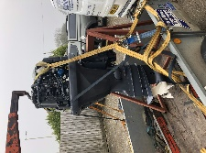
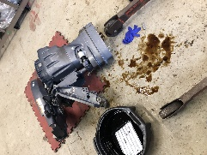
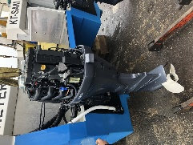This job was to replace the saddle bracket on a Selva 30xs which had become broken when the twin seas catamaran it was on, reversed into the sea wall.
This was a very technical job as the saddle bracket has bolts which run underneath the powerhead so in order to get at the bolts, we had to remove the powerhead.
We managed to get all this done within two days work and back onto the transom of the boat so that the customer could get back out on the water.
This job was for a commercial customer so he was very pleased that we could get it done so quickly.
In this I learnt a lot such as:
-How to remove the powerhead on a Selva xs30
-How to remove the saddle bracket from the midsection of the engine
-The importance of the link wires from the saddle bracket to the anodes as they prevent the electrolysis from attacking the metal and causing corrosion.
-How to work quickly and efficiently whilst removing engine parts. Rupert showed me how if you place the engine parts down on a cloth in the same order you took them off, the assembly process can be much more efficient.
-And finally, how to reassemble the engine a selva 30 xs and find the correct torque settings for the bolts online.
So far at college we have been doing an array of activities which have included stripping down and rebuilding a seagull 40 two stroke which i found very interesting as it taught me how simple the old engines used to be and i applied the knowledge from this to a seagull 40 which we had into the workshop to be worked on.
I have highly benefitted from the help I have received from shipwrights as it has allowed me to be given opportunities that has helped me become a better apprentice. Due to the sponsored first year, it has allowed Rob Perry marine to offer me the best courses available, such as Mercury University which is run by Barrus. Mercury university is an online platform which has hundreds of videos explaining how different engines and ancillary components work and this is very important to learning how to problem solve on an engine. The best way to start is always to learn how the part you are trying to repair works and at what pressure or rpm it runs at.
Another course that I have been able to undergo thanks to the funding from shipwrights is the powerboat level two course that we do in house. In this course I learnt how to do basic map and tide reading, and how to control and manoeuvre a vessel safely. To practice this, we did many drills of man overboard and finding a mark on the gps. We also did lots of putting the boat onto the pontoon and mooring up correctly and map reading skills in the class room.
I think that my work is benefitting the local community as my skills in the workplace grow because it means that if the local people need a job to be done by us, we can get to it faster as there are more of us to share the workload and we can also be more efficient. As I become more skilled it will allow me to get their job done quicker so they can get on with their days out for leisure, fishing or other commercial work.
So far, I have really enjoyed my experience from Rob Perry Marine and I feel I am continuously acquiring lots of new skills all the time and they have really made me feel like I am part of the team by including me in activities both inside and outside of work. For example, a couple of weekends ago we took part in the Lyme Regis bath tub race after building a floating bath tub on the Saturday evening. I am excited about the future and I plan to keep working hard and achieving new goals with the team throughout my apprenticeship and beyond.
Yours sincerely,
Wil Tewson.

