Harvey Sainsbury – TLC Refit and Repair, Faversham, Kent – Final progress report

It has been just over a year after joining TLC refit and repair and in these twelve months what I must add have just flown bye. All though it has been a confusing and strange few year due to the global pandemic we as a company have still tried are very best to work through and harder than ever and still have had lots of work to complete.
However, with all the travel restrictions it has been harder to work away and due to my age, I had to wait until July 2021 to receive my double vaccine. So therefore, I have been based in the workshop mind you the team have kept me very busy learning new skills.
In February we started work on octopus super yacht working on their side boarding ladder as they had broken the slew platform as a team, we think the reason for it breaking is because the crew of the vessel didn’t put the ladder on float mode. Float mode is for when the boat is moored up and the ladder is in use it will move up and down adjacent to when the boat moves due to the waves this so the ladder isn't used as a stabilizer basically for an eight-thousand-ton boat. So, to amend this problem we have to make brand new aluminium castings what took several months. Also, we had to get another piece casted this was called the back bone and the backbone strengthened the ladder. I found this part of the process interesting because it was my first time working from scratch and I was part of checking all the tolerances and looking over the casting for imperfections. While these pieces were being constructed, we were stripping the rams down making sure to give them a thorough clean and check the rods for bending due to the fact the ladder dropped this could have bent the rams however only two of them took the fall brunt of their forces. So, we only replaced the rods for them two. After replacing all the seal and fully testing the rams we sanded them all down and got them ready for painting. When all the casting returned, we had to dry fit them making sure they were a perfect fit and all in the tolerance. Making sure all the pins were a good snug fit. Then it was time to prep it for painting making sure all the services were as smooth as possible. Once all the components were painted and had been checked to make sure they was of the highest standard we rapped them up in bubble rap and black shrink ram so they was were secure and protected ready to be sent off to Marseille.
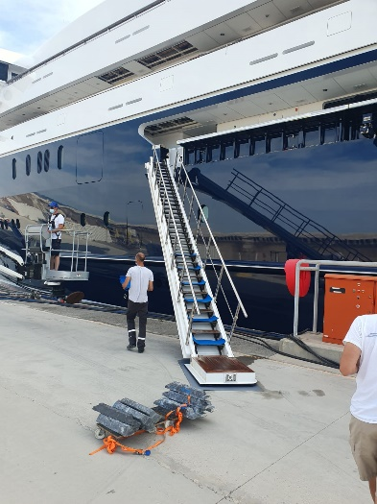Picture showing us testing the side boarding ladder.

Since January I think I have really pin pointed my errors and made sure that they have been ironed out for example making sure I check thing more than once because sometimes you can look at it and find an imperfection that you didn’t see before. I have also learned that preparation is key in any job if that’s just making sure your work area is clean or that you have the correct tools to do the job it is imperative to make sure everything is done to the highest standards.
I have attended college many times now we completed many tasks while being at college from example as a group we were asked to strip down a Volvo Penta engine removing all the maritime part and making sure we knew what every component of that engine was for. Also, we have had a look at some 2 stroke and 4 stroke engines we recently were given two 2 stroke outboard engines and we have to make one working engine out of two broken ones. I believe our next unit is welding and I am excited to learn this new skill as I believe it will become very useful in the future.

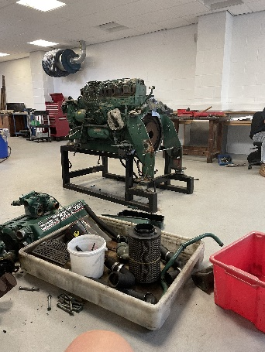Picture showing volvo penta engine and the parts we striped down.

At this point in time the restriction is being lifted so we hope to be back in full swing in the coming months and I hope to use my new skills away on jobs. We have just started a crane refit on a vessel down in Pendennis yard and as it is in England, we have brought back all the components and been able to work out of our very own workshop. This makes the job run so much smoother because we have all the necessary equipment and all the space to strip down the cranes. I have been working alongside my peers very closely and have started to take control of some jobs of my very own. One of the crane pedestals needed to be completely stripped down so I took control of doing so. Making sure to take lots of pictures and mark it all up so when it needs to go back together, we know exactly where it all goes back.
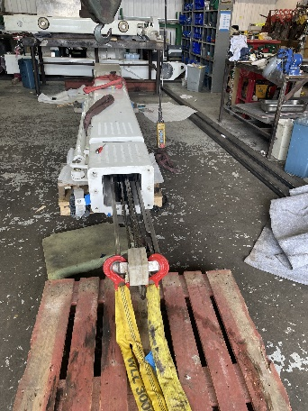Crane from Pendennis.
Since joining TLC I have learnt so much from learning from others. I think I have inspired some of my friends look for apprenticeship because I told them it was such a great way to learn a new skill. I personally think it's better learning with people because you pick up little tricks that can help you out.
I would just like to say thank you very much for granting me the money for my tools it has helped so much because your tools help you work the best you can be and the most efficient. I'm still adding tools to my tool box every month because certain jobs need specific tools for example, I needed to buy a set of micrometres to make sure my work is very precise.

