Press Release
School: George Green’s School
Principal: Jon Ryder
Contact phone number: 020 7987 6032/07966 926 421
Address: 100 Manchester Road, London, E14 3DW
Statement:
We are delighted to share another set of excellent GCSE outcomes. Our year 11 students made brilliant use of the robust, rigorous and ethical system we put in place to calculate teacher assessed grades and as a result can feel very proud of what they achieved. Students’ outcomes this year are absolutely as accurate and fair as those achieved by young people sitting exams prior to the pandemic. As such, all students can take these grades with them onto the next stage of their education with the same pride and satisfaction with a job well done as previous cohorts.
Some key headlines:
- 96 grade 9s in total
- 219 grade 8 and 9s in total
- 20% of students getting at least 1 grade 9
- 32% of students getting at least 1 grade 8 or 9
- 70% x5 grade 4+ including English & Maths
- 53% x5 grade 5+ including English & Maths
- 73% grade 4+ English & Maths threshold
- 54% grade 5+ English & Maths threshold

Quote from the Principal
“We are so pleased with another fantastic set of GCSE of results. Our students worked incredibly hard to achieve these grades and were put through an extremely rigorous and fair process to help us calculate them. We are so proud of the resilience, determination and adaptability our students have shown throughout the pandemic.
We are delighted that so many of our students have decided to join us in the George Green’s Sixth Form next year and we look forward to supporting them throughout the next stage of their education.
I am very grateful to all my colleagues for the work they have put in to getting students to this point. George Green’s staff are incredibly special group of people.
The absolutely wonderful outcomes we have received this year reflect the success the school has enjoyed over the past few years.
My congratulations also to all the parents who did such a wonderful job bringing up this incredible group of young people.”
Student quotes and case studies
Javeer Joarder (x9 grade 9s and x1 grade 8)
“I was always determined to achieve my goals. I worked hard and didn’t let anything distract me.”
Picture below: Javeer with Mr Ryder (Principal)
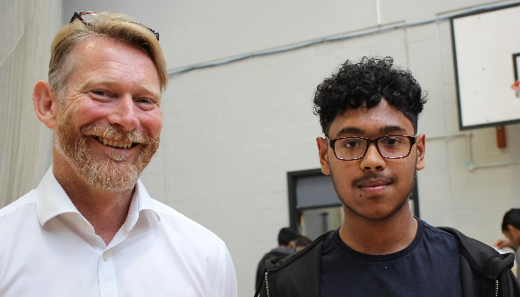
Farah Farique (x8 grade 9s and x1 grade 8)
“I adopted a positive mind set and didn’t allow disappointment or setbacks to get me down.”
Pictures below: Farah (far right) celebrates with her friends; Farah with Mr Ryder
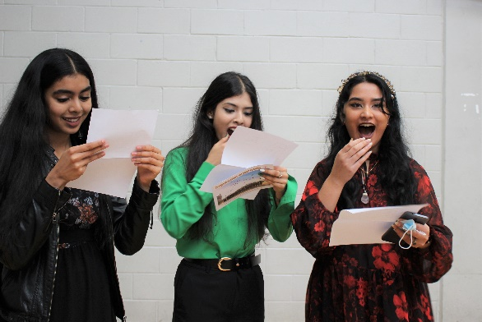
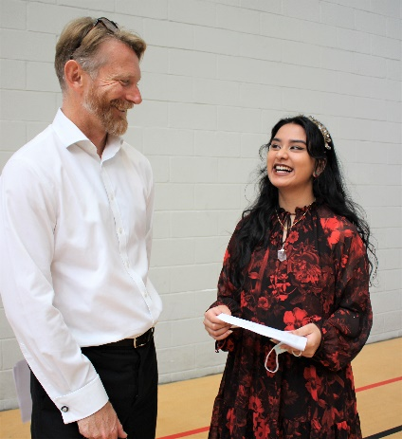
Mahfuz Abdullah (x2 grade 9s, x4 grade 8s, x2 grade 7s, x1 grade 5)
“I never gave up even when faced with challenges. I kept going and didn’t lose my focus.”
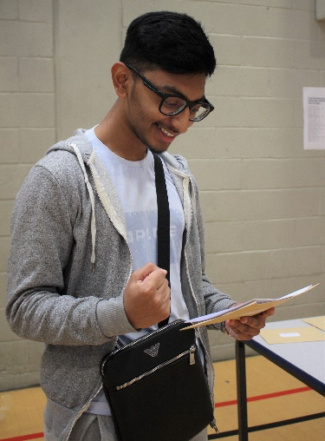
Bil-Marhamah Rahman (x3 grade 9s, x4 grade 8s, x2 grade 7s)
“I worked so hard to achieve these results. My best advice to other young people about to sit exams is to never doubt yourself. You can do it!”
