Press Release
School: George Green’s School
Principal: Jon Ryder
Contact phone number: 020 7987 6032/07966 926 421
Address: 100 Manchester Road, London, E14 3DW
Statement:
At George Green’s School we implemented a robust, rigorous and ethical process for setting grades for our A level and Btec students. We are confident that these outcomes capture the hard work and effort all our students put into their studies over the past two years.
We were very happy to welcome Mayor John Biggs and Council Asma Begum to celebrate our students’ success with us. The support from the council throughout the pandemic has been excellent.
Some key headlines:
- 100% of students achieved an A*-E
- 65% of students achieved one or more A/A*
- 1 student got 4A*s
- 12% of students achieved 3 A*
- 25% of students achieved 3 A/A*
- 54% of students achieved 3 A*-B
- 77% of students achieved 3 A*-C
- We have enjoyed some extraordinary success at A/A* in a number of subjects:
  - Biology 64% A/A*
  - Spanish 67% A/A*
  - French 50% A/A*
  - Further maths 100% A/A*
  - Maths 44% A/A*
  - Computer science 60% A/A*
  - Italian 67% A/A*
  - Chemistry 50% A/A*
  - Physics 44%
  - Economics 47% A/A*
- 77% of George Green’s students were offered place at their first choice university
- 37% were offered places at Russell Group universities

Quote from Jon Ryder, Principal:
“I am very proud of the achievements of our students. They have all demonstrated enormous resilience in the face of incredible challenges: two lockdowns during which school was closed, periods of self-isolation, and teacher absence due to Covid to name but a few. They have risen to every challenge and surpassed even our highest expectations of them.
All our students went through an extremely rigorous process in the summer term, which mirrored, as far as was possible, real exams. As such, the grades they have achieved have exactly the same value of those achieved by students prior to the pandemic.
I would like to pay tribute to my colleagues here at George Green’s School. They have been faultless in their approach to supporting their students over the past two years. These fantastic outcomes could not have been achieved without their professionalism, adaptability and sheer hard work.
We must also celebrate the parents of our students. Their support for their children, as well as the school, is a critical part in the success of these young people
We are delighted that so many of our young people will now be able to move on into the university places of their choosing.”
Student case studies and quotes:
Jakaria Ibn Khalil (Biology A*, Chemistry A*, Maths A*, Psychology A*, Extended Project Qualification A*)
Destination: UCL to study Medicine
“Teachers at George Green’s School gave me so much help and support. They pushed me to succeed. I believe that your background doesn’t matter and that everyone can succeed regardless of ethnicity or socio-economic status. It’s all about your mindset and your determination to overcome barriers.”
Picture below: Jakaria celebrates his success with his father and Mayor Biggs.
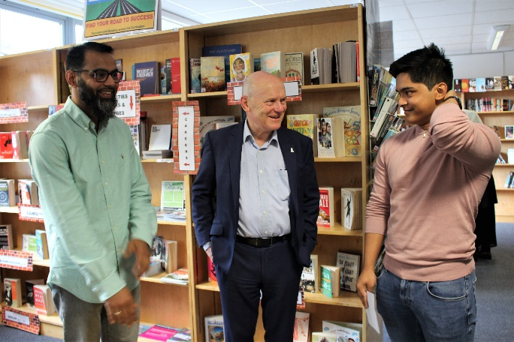
Amy Leigh-Hyer (Maths A*, Further Maths A*, Computer Science A*)
Destination: Manchester to study Computer Science
“I worked really hard for my results. My teachers gave me loads of help and support. They were always available to me to ask questions to if I was struggling on my weaker areas. My advice to other students is to always believe in yourself and your ability. And to always try your best!”
Picture below: Amy with Jon Ryder, Principal
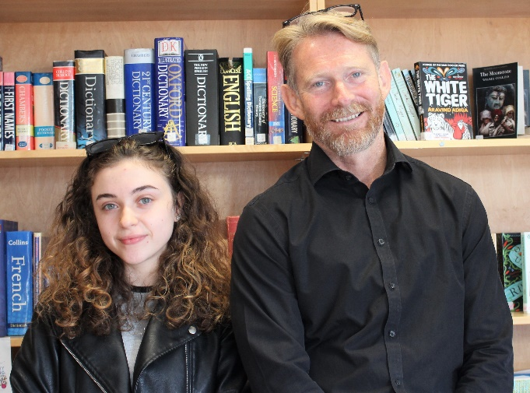
Oliur Rahman (Biology A*, Chemistry A*, Maths A)
Destination: Queen Mary (UoL) to study Dentistry
“I achieved success by learning from others around me and by following the advice of my teachers. It’s always important to take advice from successful people and to follow in their footsteps. My advice for others is to work hard, but steadily. Set yourself realistic daily goals and stick to them.”
Picture below: Oliur celebrates his success with Mayor Biggs and Council Begum
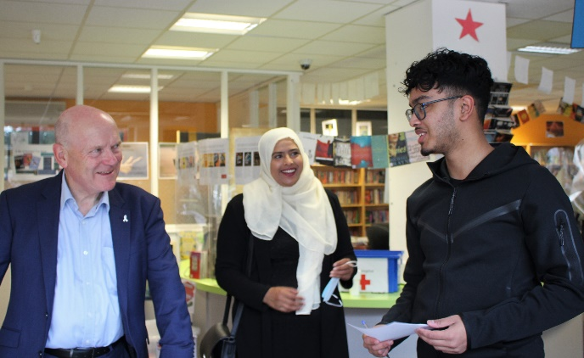
Rasmi Hakim (French B, Spanish A, Italian A*, Level 3 Btec Business Merit Merit, London Institute of Business and Finance B). This is the equivalent of 6 A levels.
Destination: Greenwich University to study International Business with French
“The secret to my success was being patient and adapting to the demands of my timetable. My advice to other students is never to give up. At times, you will feel overwhelmed, but at those times you have to dig deep and keep going.”
Picture below: Rasmi with her results
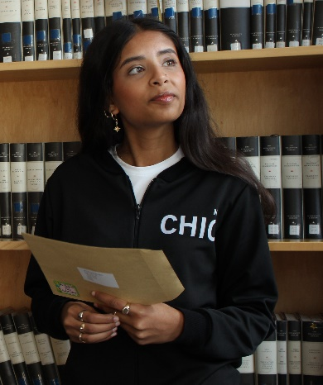
Fabeha Jahan (French A, Biology A, Chemistry A)
Destination: Southampton University to study Medicine
“I achieved my success through following the advice of my teachers. I want to say a massive thank you to them. I really believe that I wouldn’t have that level of support at any other school. My advice to other students is to listen! It always makes a difference.”
Picture below: Fabeha with her results
