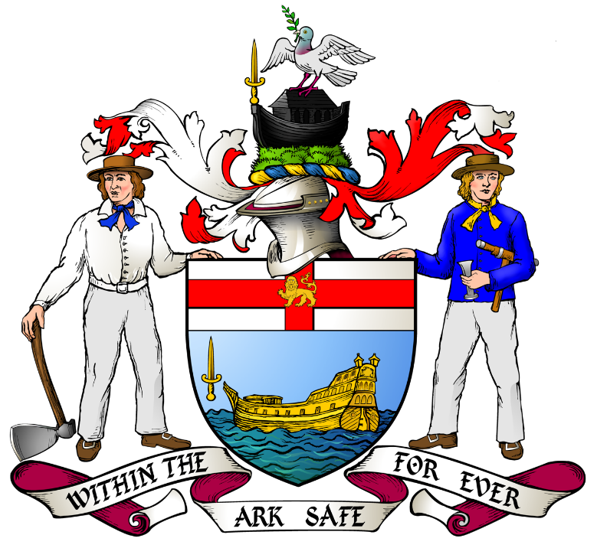

LIVERYMEN OF THE WORSHIPFUL COMPANY OF SHIPWRIGHTS
WHO HAVE BECOME ALDERMEN, SHERIFFS AND
LORD MAYORS OF LONDON

 |  | Alderman | Sheriff | Lord Mayor
1 | Edward BRENT* | 1668
2 | Thomas JAMES* | 1669
3 | Thomas WARD* |  | 1829-1830
4 | John Henry JOHNSON |  | 1873-1874
5 | George BURT |  | 1878-1879
6 | Thomas BEVAN* |  | 1878-1879
7 | Reginald HANSON | 1880-1905 | 1881-1882 | 1886-1887
8 | William ANDERSON OGG |  | 1881-1882
9 | James WHITEHEAD | 1882-1896 | 1884-1885 | 1888-1889
10 | Joseph SAVORY | 1883-1920 | 1882-1883 | 1890-1891
11 | James Ebenezer SAUNDERS | 1887-1888
12 | Horatio David DAVIES | 1889-1912 | 1887-1888 | 1897-1898
13 | Alfred James NEWTON | 1890-1921 | 1888-1889 | 1899-1900
14 | Harry Seymour FOSTER |  | 1891-1892
15 | James Thompson RITCHIE* | 1891-1912 | 1896-1897 | 1903-1904
16 | Thomas Robert DEWAR* |  | 1897-1898
17 | William Henry DUNN | 1909-1923 | 1906-1907 | 1916-1917
18 | George Rowland BLADES (a) | 1920-1948 | 1917-1918 | 1926-1927
19 | William Lacon THRELFORD |  | 1932-1933
20 | Denys Colquhoun Flowerdew LOWSON | 1942-1973 | 1939-1940 | 1950-1951
21 | Frank Samuel ALEXANDER* | 1938-1939 | 1940-1941 | 1944-1945
22 | Norman Cleverton TREMELLEN |  | 1953-1954
23 | Arnold Charles TRINDER | 1959-1976 | 1964-1965 | 1968-1969
24 | Charles Gundrey ALEXANDER | 1970-1976
25 | John Garrow Maclachlan HART* |  | 1979-1980
26 | Richard Christopher Larkins CHARVET* | 1976-1984 | 1983-1984
27 | Jack Edward NEARY* |  | 1985-1986
28 | Frederick Michael EVERARD* | 1996-2000
29 | David Bilsland COBB* |  | 2004-2005
30 | Jeffrey Richard de Corban EVANS* (b) | 2007-2018 | 2012-2013 | 2015-2016

The mother company of those marked * is known to be the Worshipful Company of Shipwrights

(a) Lord Ebbisham (1st Baron Ebbisham)
(b) Lord Mountevans (4th Baron Mountevans)

