Spring 2017 Newsletter

Last year was a very successful one for Medusa, the highpoint being our trip to Dunkirk for filming. The film is due for release in July and it will be quite something to see Medusa on the big screen. Once the film is out, we are released from confidentiality and more can be said about what we actually did. Last year we also did some filming for the History channel and this has gone out as Episode 4 of a series “Combat Ships” entitled “Ships that Saved D Day”. It was particularly nice that our one surviving crew member who was on Medusa all through WW2 was featured.

This year got off to a flying start with a day out for cadets from Warsash Sea Cadets as part of the navigation training. It was February and bitterly cold and we came back in with the cadets all huddled round the heater in the wardroom thawing out. The day was a success and will be repeated.

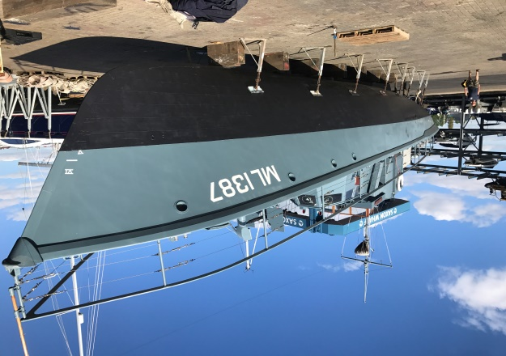
Medusa has been approved by the Royal Navy for taking Combined Forces Cadets to sea and we have the first of these booked for July for cadets from Charterhouse with interest from several other CCF sections. This is an area we are keen to expand and have been pleasantly surprised at how engaged the cadets are with the vessel.

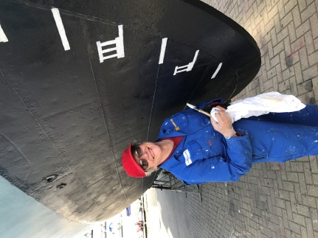
April 10 saw us going to Saxon Wharf for our annual lift out. We had allowed nine days for this but were all done in a record three and back on our berth on the 13th. As last year, the yard could not believe the speed we worked at.

With Medusa looking smart, we took part in the Royal Navy Squadex17 which consisted of 14 of the P2000 fast patrol boats of the First Patrol Boat Squadron, MGB81 and Medusa. The event started with a social gathering at the Invincible Pub in Portsmouth and was a great evening, enlivened by the adjacent Fish and Chip shop going up in flames. The following day was a briefing followed by a practise with seven P2000s; I was lucky enough to go out on HMS Ranger and watch.
Tuesday morning 0915, two columns of seven vessels left harbour in formation, a sight last seen in 2004. Medusa was tail end of the starboard column and 81 the port. We held formation with various course alterations until past the forts when we all turned East. I was very grateful for the RN yeoman on board translating the manoeuvring commands into something understandable.

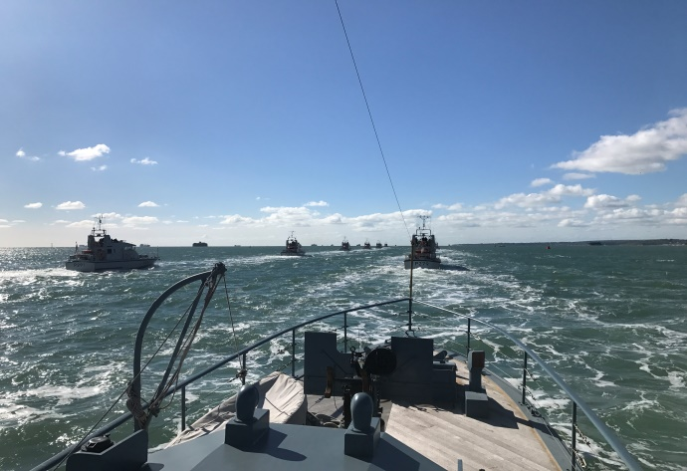
Then came the interesting bit. We transitioned from line ahead into a broad Vee formation with Medusa moving up to form the shaft of the arrow just astern the leading boat. We had anticipated that fine adjustment of speed would be needed for station keeping and had agreed between bridge and engine room to set “half ahead” as convoy speed and then a short push on the engine room alarm bell would mean “up 25 revs” and a long “down 25 revs”. Surprisingly it worked perfectly.
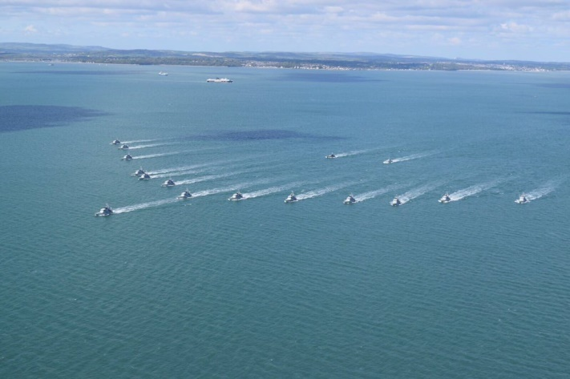

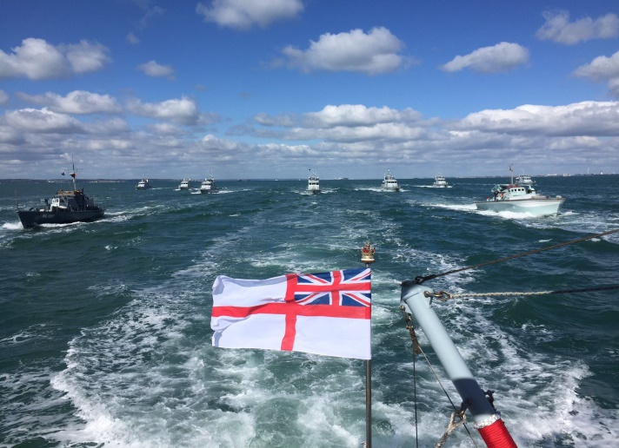
The next transition involved half the boats ahead dropping back to form a Vee ahead of us and another astern. This was delicate stuff as we were well and truly boxed in. After steaming in that formation for a while we moved to a rectangular formation with Medusa one side of the box and 81 the other.

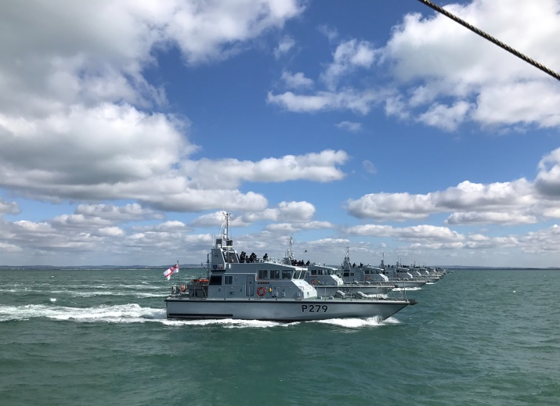

Finally, we transitioned to line abeam with Medusa out on the starboard side. That was our bit completed and we curved away to starboard and headed for home.

The final part of the day was a lunch for commanding officers at 1 The parade in the Naval Base. It was a privilege to be asked to attend this and I am in awe of the young men and women that commanded the vessels; their confidence and competence is just stunning.
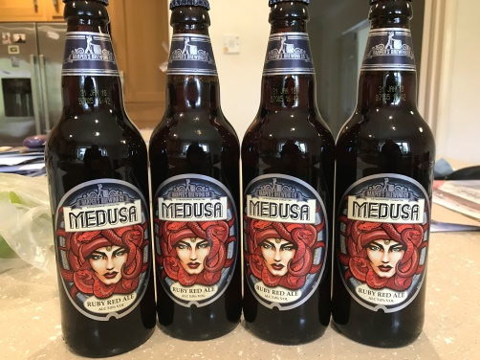

It was all a great success and we rewarded ourselves with a little of Medusa’s own brew. It would be nice but dishonest to say it had been made for us; the truth is that Ian spotted it in a supermarket and their sales went up immediately.

May 9th saw us back at sea again. We were contacted by Neil Cave of TLE photographers who wanted us for a photo shoot. Luckily the weather was perfect on the day and we did some shots with the RAF rescue launch HSL102 in the morning before going to Sandown Bay, IoW, where there were white cliffs on the shore side and a clear horizon to sea. It was slightly surreal to be asked to go at full speed directly at the camera boat and pass as close as possible but the pictures taken by the photographers were amazing. To add to the effect, we dressed the part and had a team of re-enactors on board. I think we frightened a sailing boat when we passed with gun crews closed up.

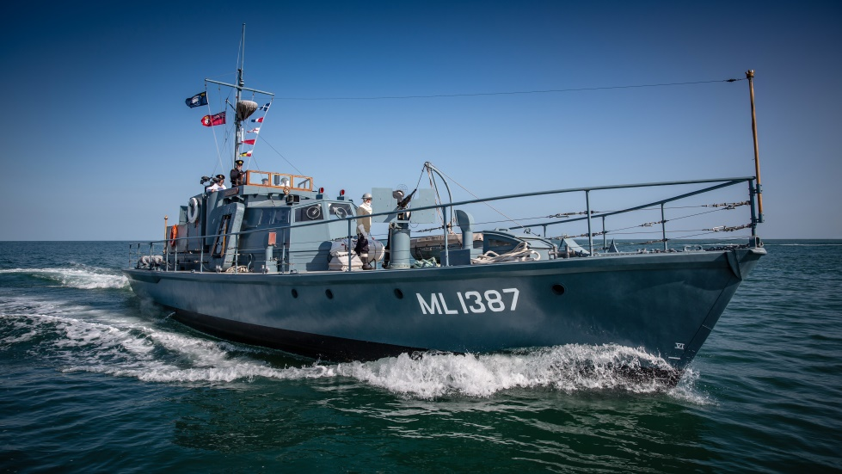
(Picture courtesy of Fourelements Photography)

Looking ahead we have the Gosport festival at Haslar on 27th this month followed by a similar event at Hythe on the 28th. We plan to overnight on the Harbour Master’s jetty at Warsash; when I phoned, they were really excited about us coming and nothing was too much trouble.
All being well, we plan to cross the Channel on the 31st for D Day commemorations and may even take in the Channel Islands. There should be plenty for my next report.
As ever, thanks go to our volunteers and supporters without whom none of this would be possible.

